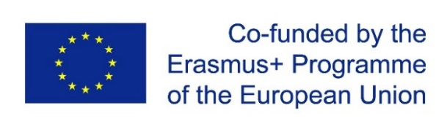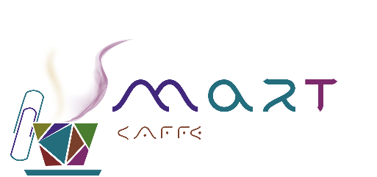

ERASMUS+ PROGRAMME, KEY ACTION 2

CAPACITY BUILDING IN HIGHER EDUCATION

Fostering university-enterprise cooperation and
entrepreneurship of students via SMART Caffes (SMART)

SMART ONLINE HACKATHON

AGENDA

2nd – 3rd September 2021

Organizer and facilitator: Varna University of Management (VUM), www.vum.bg
Venue: www.zoom.us

2nd September 2021, Thursday

SMART Online Hackathon: Day 1

Time: 09:00 AM Brussels

9:00 – 09:30 Brussels time | Registration
09:30 – 10:00 Brussels time | Meet and greet: opening remarks  Expectations of the hackathon: presentation of the two-day event agenda
10:00 – 10:45 Brussels time | Improvisation exercises
10:45 – 11:00 Brussels time | Coffee break
11:00 – 12:00 Brussels time | Presentation of Albena JSC and company’s COVID-19 related challenges subject to open innovation
12:00 – 12:30 Brussels time | Lunch break
12:30 – 13:30 Brussels time | Crash course in pitching and presenting
13:30 – 14:30 Brussels time | Ideation breakout sessions 1.
14:30 – 14:45 Brussels time | Coffee break
14:45 – 15:45 Brussels time | Ideation breakout sessions 2.
15:45 – 16:00 Brussels time | Wrap-up of hackathon’s day 1.

3rd September 2021, Friday

SMART Online Hackathon: Day 2

Time: 09:00 AM Brussels

9:00 – 09:45 Brussels time | Recap and what’s next
9:45 – 11:15 Brussels time | Pitch preparation and rehearsal breakout sessions
11:15 – 11:30 Brussels time | Coffee break
11:30 – 12:30 Brussels time | Pitching of challenges’ solutions 1.
12:30 – 13:00 Brussels time | Lunch break
13:00 – 14:30 Brussels time | Pitching of challenges’ solutions 2.
14:30 – 15:00 Brussels time | Assessment and evaluation of student teams’ pitched solutions
15:00 – 15:15 Brussels time | Hackathon results’ announcement
15:15 – 15:30 Brussels time | Debriefing and closing session

Contact point during the two-day event:
Project team of VUM
Email: erasmus@vumk.eu

